Practical 3

Topology

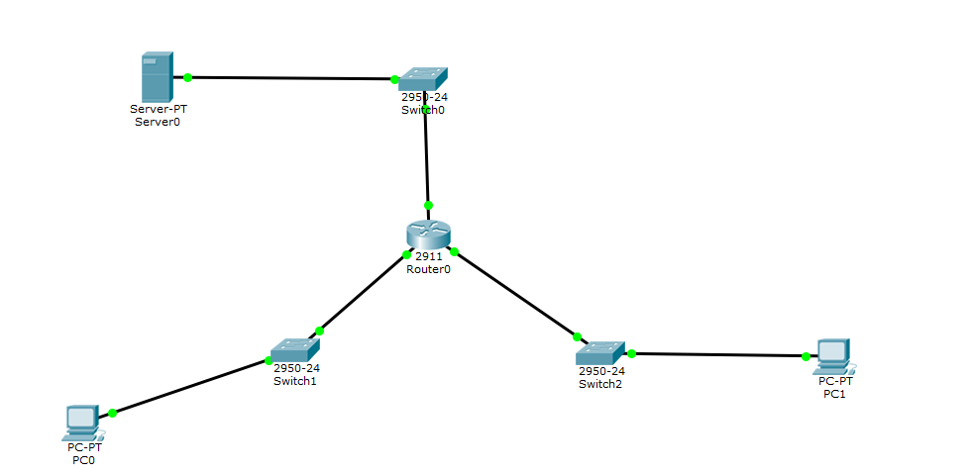

Table:

|  |  |  |  |  |
| --- | --- | --- | --- | --- |
| Device | interface | IP Address | Subnet Mask | Default Gateway |
| R1 | G0/0 | 172.22.34.65 | 255.255.255.224 |  |
|  | G0/1 | 172.22.34.97 | 255.255.255.240 |  |
|  | G0/2 | 172.22.34.1 | 255.255.255.192 |  |
| Server |  | 172.22.34.62 | 255.255.255.192 | 172.22.34.1 |
| PC1 |  | 172.22.34.66 | 255.255.255.224 | 172.22.34.65 |
| PC2 |  | 172.22.34.98 | 255.255.255.240 | 172.22.34.97 |
|  |  |  |  |  |

Code:

After configuration

Run this command in router cli

Router(config)#access-list ?

<1-99> IP standard access list

<100-199> IP extended access list

Router(config)#access-list 100 ?

deny Specify packets to reject

permit Specify packets to forward

remark Access list entry comment

Router(config)#access-list 100 permit ?

ahp Authentication Header Protocol

eigrp Cisco's EIGRP routing protocol

esp Encapsulation Security Payload

gre Cisco's GRE tunneling

icmp Internet Control Message Protocol

ip Any Internet Protocol

ospf OSPF routing protocol

tcp Transmission Control Protocol

udp User Datagram Protocol

Router(config)#access-list 100 permit ?

ahp Authentication Header Protocol

eigrp Cisco's EIGRP routing protocol

esp Encapsulation Security Payload

gre Cisco's GRE tunneling

icmp Internet Control Message Protocol

ip Any Internet Protocol

ospf OSPF routing protocol

tcp Transmission Control Protocol

udp User Datagram Protocol

Router(config)#access-list 100 permit tep ?

% Unrecognized command

Router(config)#access-list 100 permit tcp ?

A.B.C.D Source address

any Any source host

host A single source host

Router(config)#access-list 100 permit tcp 172.22.34.66 ?

A.B.C.D Source wildcard bits

Router(config)#access-list 100 permit tcp 172.22.34.66 0.0.0.31 ?

A.B.C.D Destination address

any Any destination host

eq Match only packets on a given port number

gt Match only packets with a greater port number

host A single destination host

lt Match only packets with a lower port number

neq Match only packets not on a given port number

range Match only packets in the range of port numbers

Router(config)#access-list 100 permit tcp 172.22.34.66 0.0.0.31 host 172.22.34.62 ?

dscp Match packets with given dscp value

eq Match only packets on a given port number

established established

gt Match only packets with a greater port number

lt Match only packets with a lower port number

neq Match only packets not on a given port number

precedence Match packets with given precedence value

range Match only packets in the range of port numbers

Router(config)#access-list 100 permit tcp 172.22.34.66 0.0.0.31 host 172.22.34.62 eq ftp ?

dscp Match packets with given dscp value

established established

precedence Match packets with given precedence value

Router(config)#access-list 100 permit tcp 172.22.34.66 0.0.0.31 host 172.22.34.62

Router(config)#access-list 100 permit icmp 172.22.34.66 0.0.0.31 host 172.22.34.62

Router(config)#interface gigabitEthernet 0/0

Router(config-if)#ip access-group 100 in

Router(config-if)#

PC0

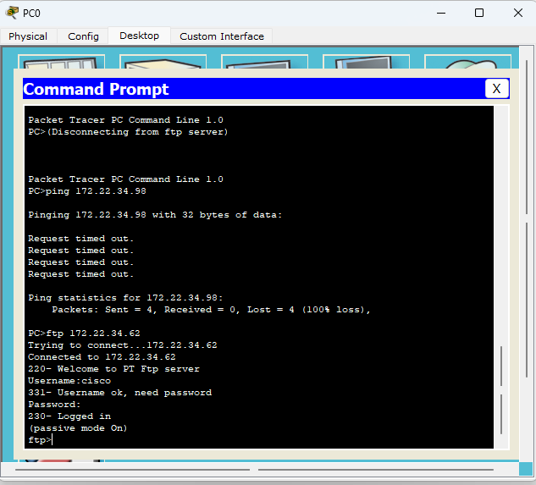

Part 2:

